**MONGO DB**

mongod.exe --dbpath "C:\data“

Mongo.exe

**Comparison between SQL and MongoDB (No SQL)-**

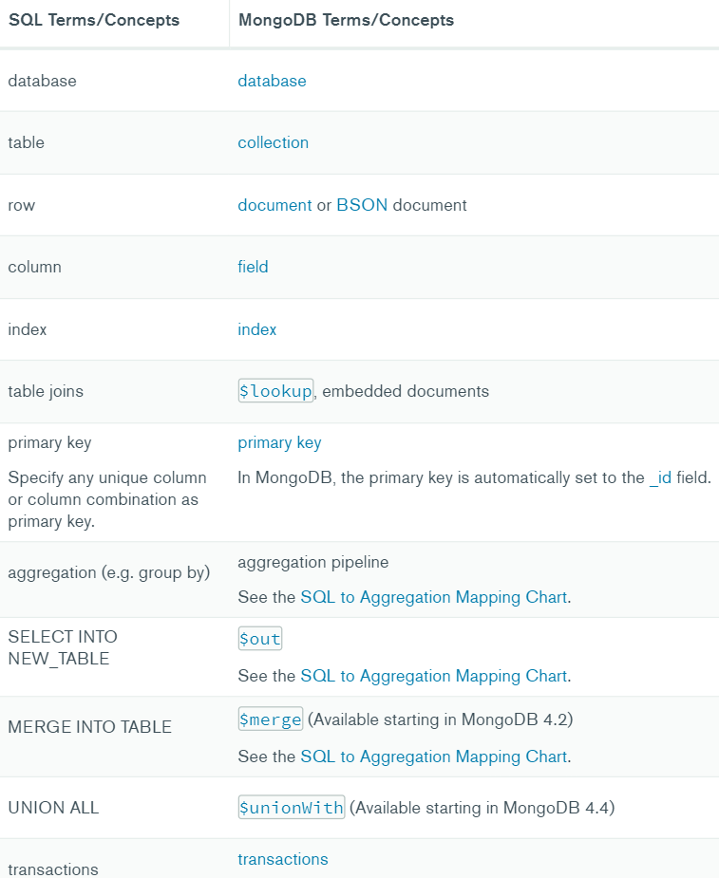

**Show databases-**

* show dbs
* OR show databases

**Select database-**

* Use mydb

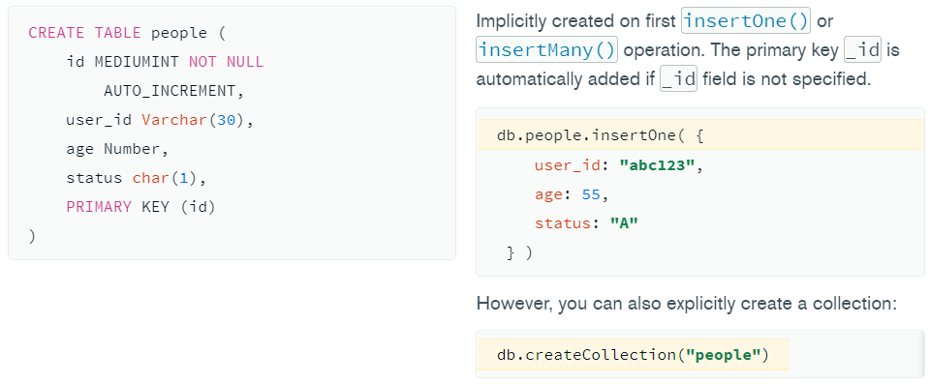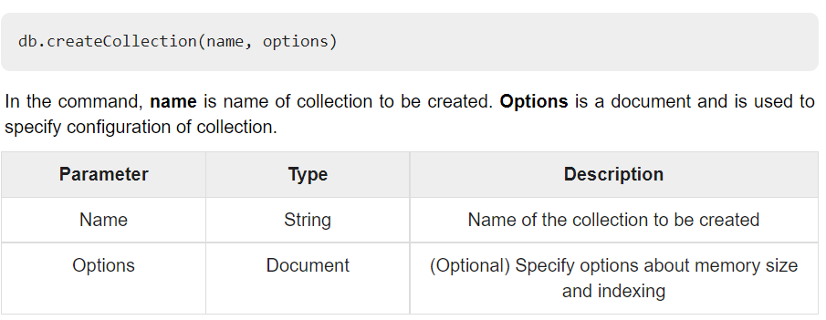**CREATE table (Collection)-**

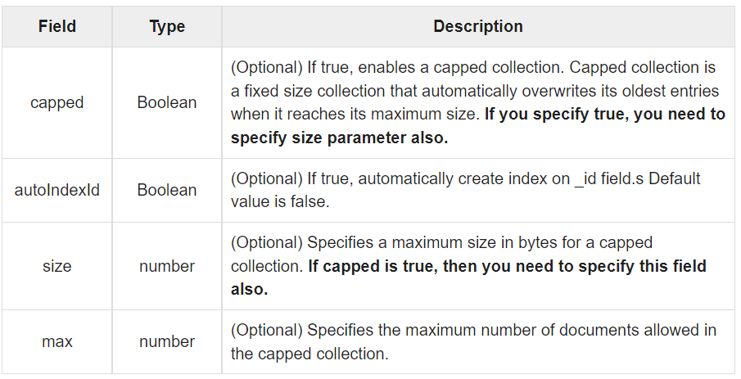

* db.createCollection("bajaj", {capped:true, autoIndexID: true, size: 6142800, max:10000})

**DROP-**

* db.COLLECTION_NAME.drop()
* show collections

**INSERT-**

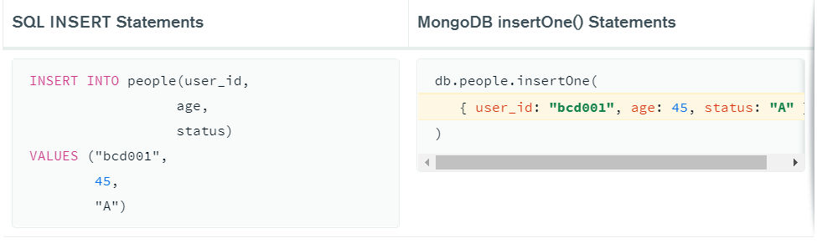

>db.COLLECTION_NAME.insert(document)

* db.bajaj.insertOne({ empid:10, empname:"Shashank" } )
* db.bajaj.insertMany( [ { empid:11, empname:"Mihir" }, { empid:12, empname:"Pranv" } ] )

**SELECT OR FIND-**

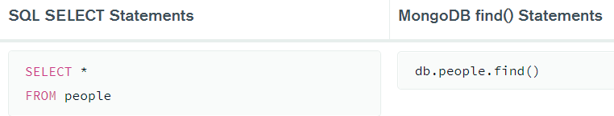

>db.COLLECTION_NAME.find()

>db.COLLECTION_NAME.find().pretty()

* db.bajaj.find()
* db.bajaj.find.pretty()

>db.COLLECTIONNAME.findOne()

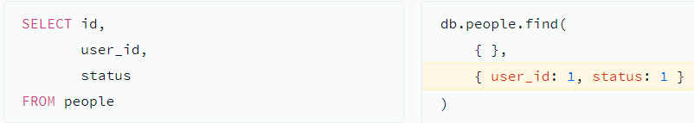

* db.bajaj.find({ }, {empid:1, empname:1})

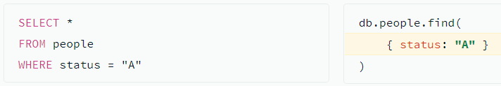

* db.bajaj.find({empid:10})

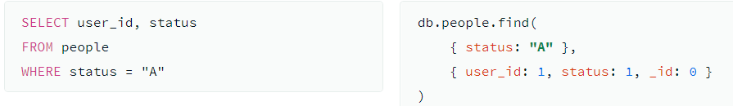

* db.bajaj.find({empid:10}, {empid:1, empname:1})

**NOT EQUAL-**

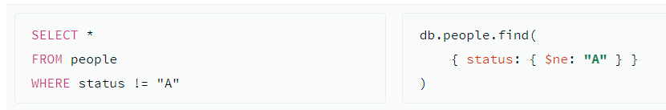

* db.bajaj.find({empid: {$ne:10}})

**AND-**

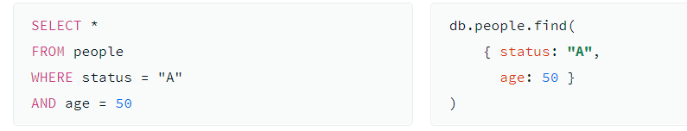

* db.bajaj.find({empid:10, empname:"Shashank"})
* db.bajaj.find({$and: [{empid: {$ne: 10}}, {empid: {$ne: 11}}]})

**OR-**

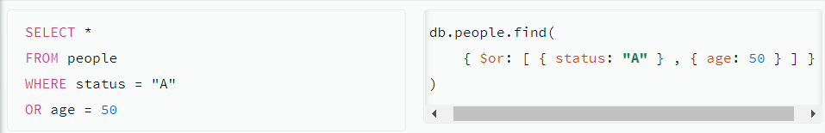

* db.bajaj.find({$or: [{empid: {$ne: 10}}, {empid: {$ne: 11}}]})
* db.bajaj.find({$or: [{empid:10}, {empid:11}]})

**GREATER THAN/LESS THAN-**

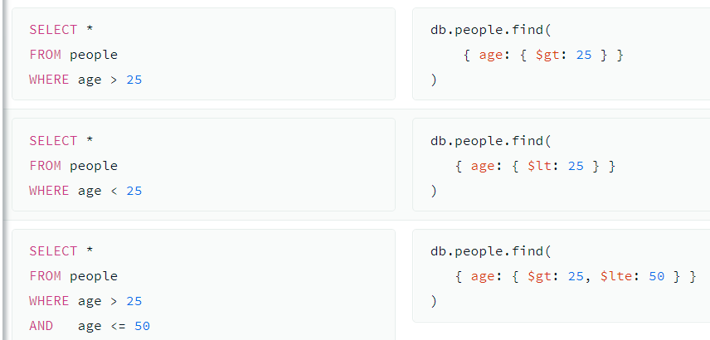

* db.bajaj.find({empid: {$gt: 11}})
* db.bajaj.find({empid: {$gt: 10, $lte: 12}})

**LIKE-**

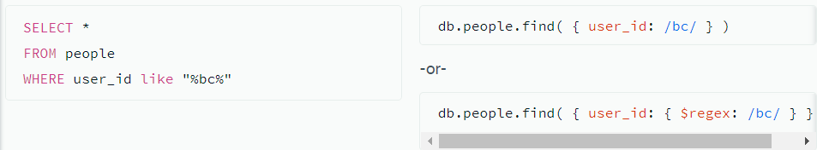

* db.bajaj.find({empname: /sha/})
* db.bajaj.find({empname: {$regex: /sha/}})

**ORDER BY-**

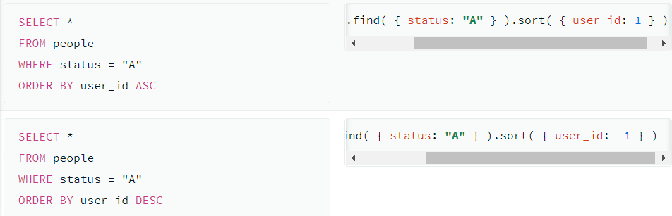

* db.bajaj.find().sort({empid:1})
* db.bajaj.find().sort({empid:-1})

**LIMIT/FIND-**

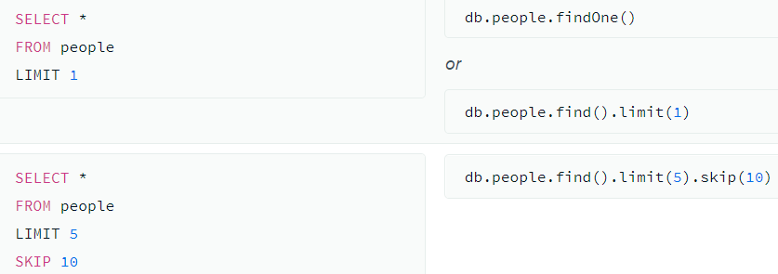

* db.bajaj.findOne()
* db.bajaj.find().limit(1)
* db.bajaj.find().limit(1).skip(2)

**UPDATE-**

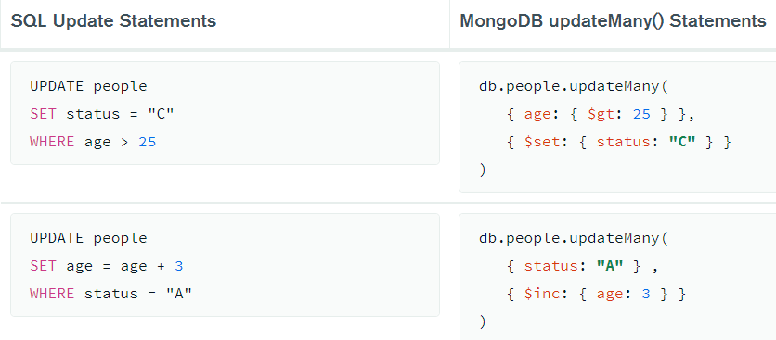

>db.COLLECTION_NAME.update(SELECTION_CRITERIA, UPDATED_DATA)

* db.bajaj.updateMany({empid:13}, {$set:{salary:2000}})
* db.bajaj.updateMany({empid:13}, {$inc:{salary:2000}})

**DELETE-**

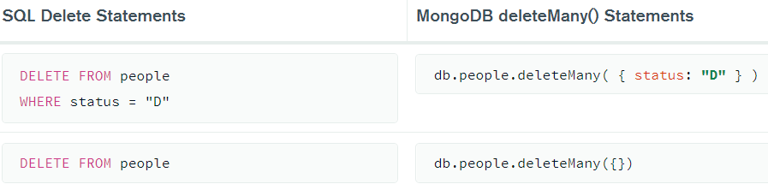

>db.COLLECTION_NAME.remove(DELLETION_CRITTERIA)

**AGGREGATE FUNCTIONS-**

**DISTINCT-**

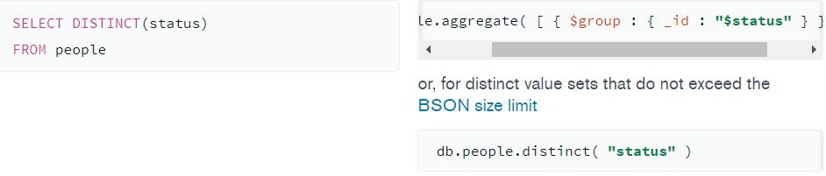

* db.bajaj.distinct("empid")

**COUNT-**

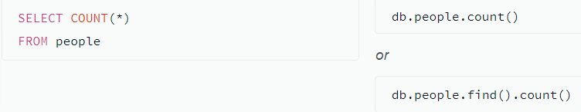

* db.bajaj.find().count() -> will give only count

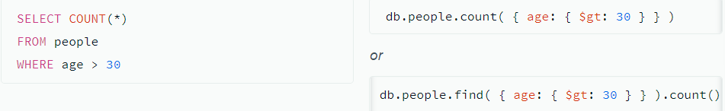

* db.bajaj.find({empid: {$gt:11}}).count() -> only count (select count(*))

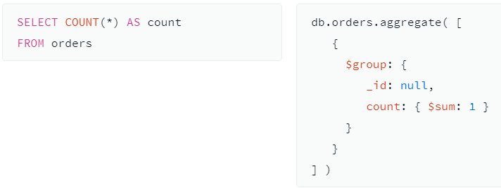

* db.bajaj.aggregate([{ $group: {_id:null, count: {$sum: 1}}}])

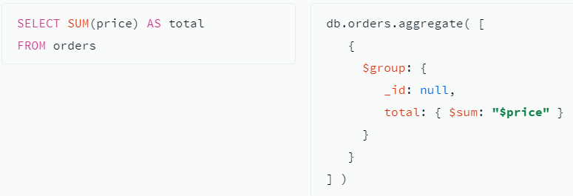

* db.bajaj.aggregate([ {$group: { _id:null, total: {$sum: "$empid"}}}])

**GROUP BY-**

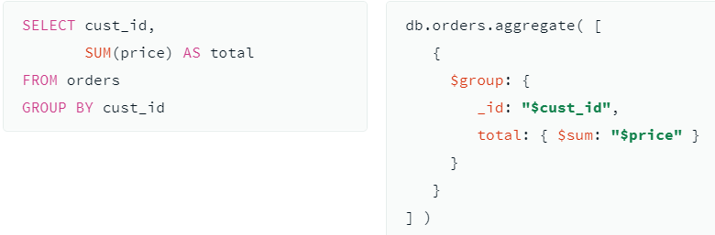

* db.bajaj.aggregate([{$group: {_id: "$empid", total: {$sum: "$empid"}}}])

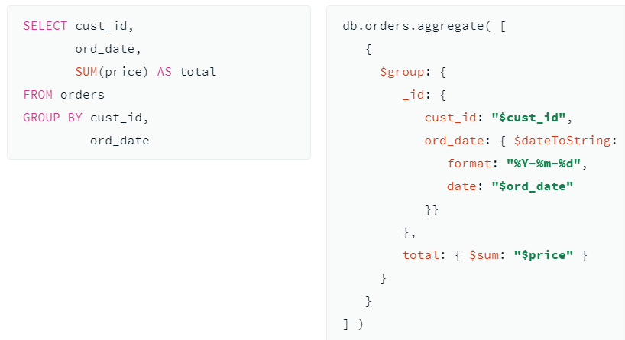

* db.bajaj.aggregate([{$group: {_id: {empid:"$empid", empname:"$empname"}, total: {$sum: "$empid"}}}])

**HAVING-**

